# CS 255 System Design Document Template

**Amauri Hopewell**

**CS255**

**Project 2**

This document lays out the basic design overview for the DriverPass software, including use case diagrams, activity and sequence diagrams, and technical requirements.

## UML Diagrams

### UML Use Case Diagram

**

### UML Activity Diagrams

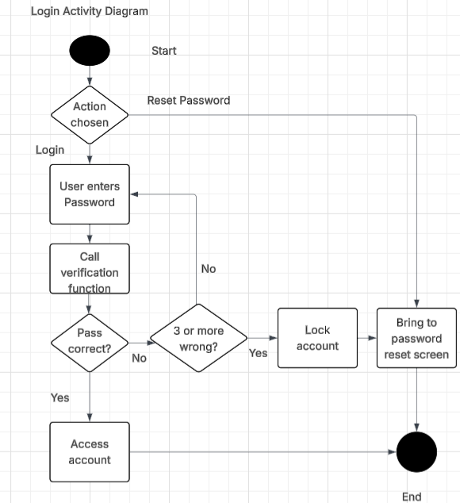

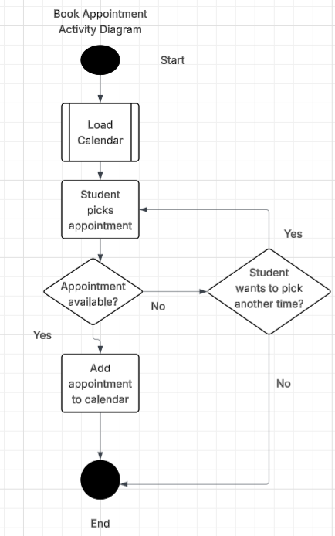

### UML Sequence Diagram (login)

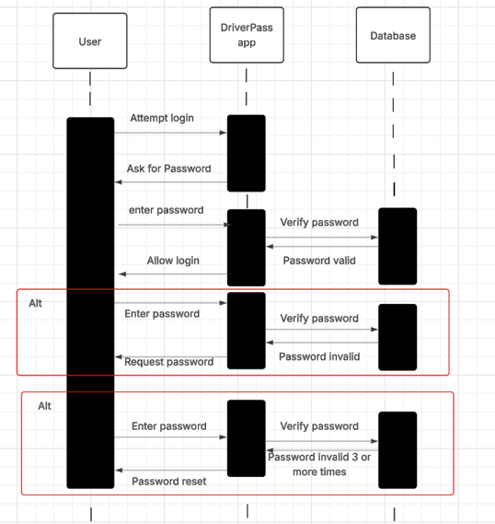

### UML Class Diagram

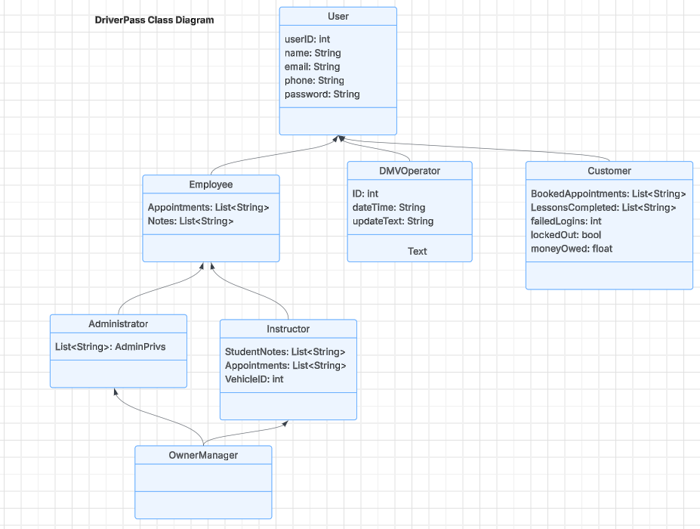

## Technical Requirements

* Hardware
  + Server or serverless cloud equivalent for running app and database
  + Mobile device or computer for users and employees
  + Internet connection hardware (router, modem, etc)
* Software
  + Stable release of Windows Server or Linux equivalent
  + MongoDB for database
  + Security and antivirus software
  + Java Virtual Machine
  + Android Studio and SwiftStudio for mobile development
* Infrastructure
  + Reliable internet connection
  + Mobile data connection
  + Reliable software security updates by Microsoft or Linux server project